**CASA of the Northern Bluegrass Region**

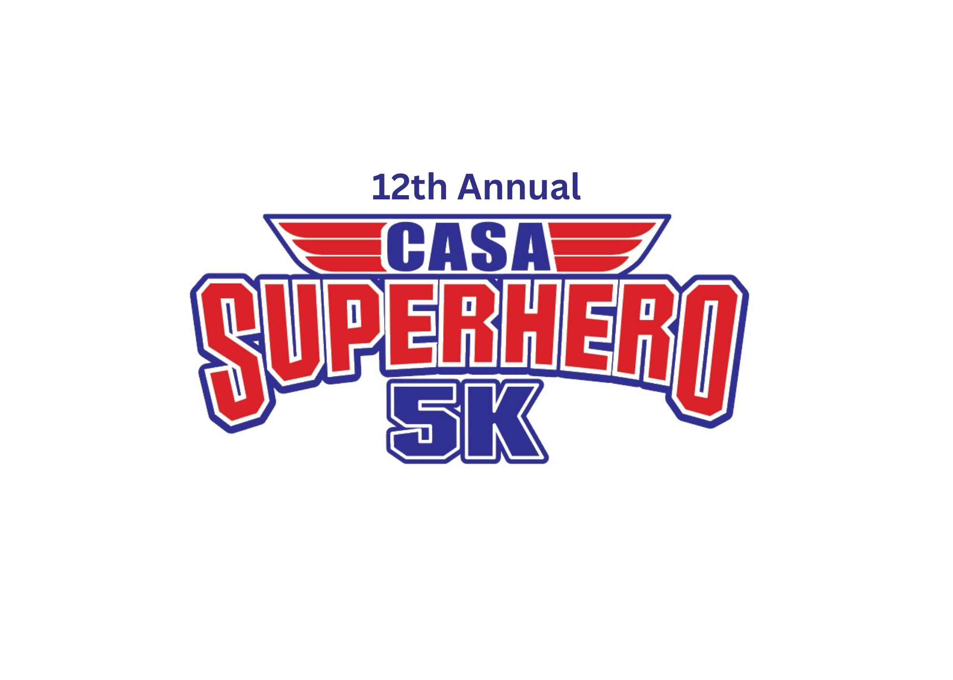

**SPONSORSHIP PACKET**

Race Date: September 13, 2025

Idlewild Park

Burlington, KY

**Please Consider Sponsoring!**

**Support CASA of the Northern Bluegrass**

(Boone, Campbell, Carroll, Gallatin, Grant, Harrison, Kenton, Owen, & Pendleton Counties)

The **annual Superhero 5K Run/Walk** is CASA of the Northern Bluegrass Region’s largest fundraiser—and we need your help to make it a success!

**CASA** stands for **Court Appointed Special Advocates**. Our mission is to provide trained, court-appointed volunteers who advocate for children who have experienced abuse and neglect—ensuring they are safe, have a stable home, and the opportunity to thrive.

CASA volunteers are a consistent presence in the lives of vulnerable children, guiding them through the complex court system until they achieve a permanent, safe placement. Volunteers ensure children receive necessary services and support family reunification when safe and possible. When that’s not an option, they work to secure stable and loving alternatives—so no child slips through the cracks.

**Why CASA Matters**

* Children with a CASA volunteer are **3x more likely to find a safe, permanent home**.
* They spend **less time in foster care**.
* They are **more likely to graduate**, go to college, and become contributing members of society.
* They are **less likely to return to the system** as adults.

In 2024 alone, **92 dedicated CASA volunteers** served **231 children** across our nine-county region. This vital work is made possible through **grants, private donations, and community fundraisers** like the Superhero 5K.

**Be the Difference**

**Become a sponsor and help us continue this life-changing work.**  
Your support directly impacts local children and gives them a voice in the courtroom—and hope for a brighter future.

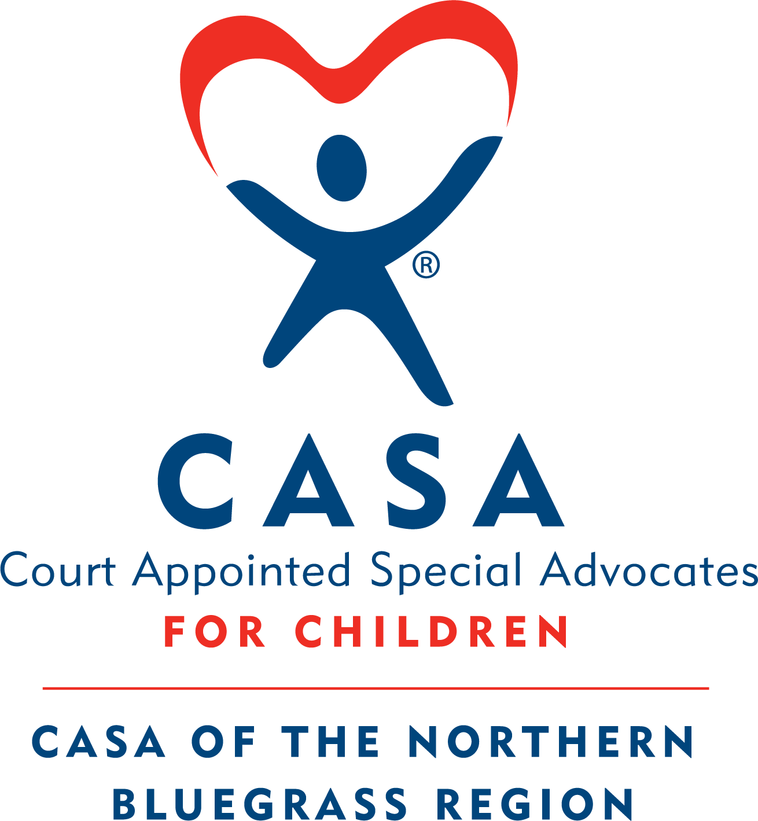

**SPONSORSHIP LEVELS**

* **DIAMOND/EVENT SPONSOR - $5,000 and higher**
  + Prominent Company logo on all advertisements & on the back of our race T-shirt at the top
  + Company logo included on 2 extra large race promotional banners
  + Name and logo prominently displayed as “Event Sponsor” at event
  + Special recognition at the event and any advertisements leading up to the event.
  + Prominent recognition and logo on the CASA website
  + 10 free race registrations
  + Option to setup a vendor table
* **PLATINUM SPONSOR - $2,500**
  + Extra Large Company logo on the back of the 5k T-shirt
  + Company logo included on 1 large race promotional banner
  + Company logo on the CASA website
  + 6 free race registrations
  + Option to setup a vendor table
* **GOLD SPONSOR - $1,000**
  + Large logo on back of the 5k T-shirt
  + Company logo on the CASA website
  + Recognition with logo on Gold sponsor banner
  + 4 free race registrations
  + Option to setup a vendor table
* **SILVER SPONSOR - $500**
  + Name listed on the back of the 5k T-shirt
  + Special recognition on the CASA website
  + Company name on a banner with other level sponsors
  + 3 free race registrations
  + Option to setup a vendor table
* **BRONZE SPONSOR - $250**
  + Recognition on the CASA website
  + Recognition on 5k Race Day banner created for the event
  + Company name on a banner with other level sponsors
  + 2 free race registrations
  + Option to setup a vendor table
* **FRIEND OF CASA – LESS THAN $250**
  + Recognition on the CASA website (for sponsors of $50 and above)
* **VENDORS - $100**
  + If you are interested in setting up a table please contact Nicky Jeffries at 859-426-2030 or email njeffries@casanorthernbluegrass.org. Your company will receive recognition at the event.
* **IN-KIND DONATIONS**:
  + If your company would like to make a donation of a product, gift card(s) or service, please contact Nicky Jeffries at 859-426-2030 or njeffries@casanorthernbluegrass.org. You/your company will receive recognition at the event.

**DEADLINE FOR SPONSORSHIP IS AUGUST 31, 2025**

**Please provide a company logo in vector format along with your check. The logo must be received by August 31, 2025 to be included on the t-shirt. If there is a problem providing your logo in this format, please contact Nicky Jeffries: njeffries@casanorthernbluegrass.org**

**THANK YOU IN ADVANCE FOR YOUR HELP AND CONSIDERATION!!**



**12TH ANNUAL 5K**

**SPONSORSHIP FORM**

Tax ID # 26-1158314

Contact Name:____________________________________________ Amount Enclosed:_____________

COMPANY NAME (If a Company Sponsor):

Address: ____________________________________________________________________

____________________________________________________________________

____________________________________________________________________

Telephone:_______________________________________

Email: ____________________________________________ Website:__________________________________

__________ Diamond Sponsor $5,000 and Up (Event Sponsor)

__________ Platinum Sponsor $2,500

__________ Gold Sponsor $1,000

__________ Silver Sponsor $500

__________ Bronze Sponsor $250

__________ Friend of CASA (Amount: __________________)

__________ Vendor $100

__________ In-Kind Donation Sponsor (Item: ______________________________________________)

Please make checks payable to: CASA of the Northern Bluegrass Region

Attn: Nicky Jeffries

500 Thomas More Pkwy, Ste. 4

Crestview Hills, KY 41017

Phone: 859-426-2030/ Email: njeffries@casanorthernbluegrass.org